**RESULT OF TWITTER SENTIMENT ANALYSIS**

**Method 1: Using NaiveBayesClassifier**

Accuracy is 76.3%

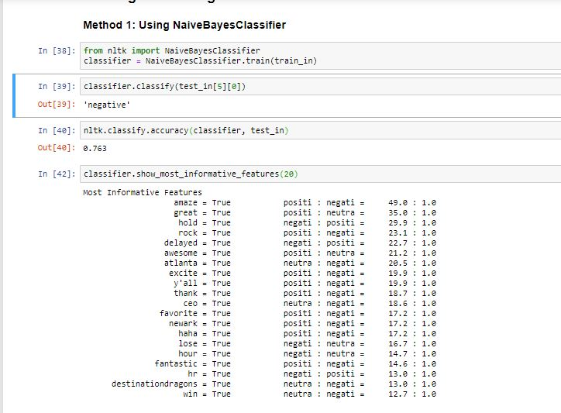

**Method 2: Using RandomForestClassifier**

Accuracy is 72.6%

